AU SOCI Compliance for Log360
Protect critical infrastructure and meet AU SOCI compliance with Log360.
Region: Australia | Type: Cybersecurity Framework, Critical Infrastructure, Incident Management, Operational Resilience | Category: Compliance | Pricing: Free

Overview
The AU SOCI compliance extension in Log360 helps organizations meet the Security of Critical Infrastructure Act 2018 (SOCI Act, Australia), Australian law requiring critical infrastructure owners to maintain asset registers, report cyber incidents within 12 and 72 hours, and implement risk management programs by providing centralized log management, real-time threat detection, and incident tracking capabilities. The platform supports AU SOCI requirements for governance, asset management, incident reporting, access control, cyber risk programs, network security, business continuity, and supply chain risk.
For Governance and CIRMP Oversight, Log360 tracks AD policy changes, GPO configurations, user auditing, group management, and computer asset changes. To address Critical Asset Registration and Management, the platform monitors Windows program inventory, software updates, registry changes, and vulnerability scanner integration. The extension also supports Cyber Incident Reporting (12h and 72h) by providing capabilities that provides threat detection from FireEye, Trend Micro, McAfee, network attack logs, and Windows threat reports.

Key Features
- Access Control and Personnel Security: Log360 captures Windows and Unix logon/failed logon events, AD MFA logon, and password compliance reports.
- Cyber Risk Management Program (CIRMP): Log360 aggregates Windows system events, EventLog data, threat detection reports, and vulnerability scanner outputs for risk documentation.
- Network Security and Monitoring: Log360 audits network device logon, account management, policy changes, attack reports, and firewall security configurations.
- Business Continuity and Cyber Exercises: Log360 monitors Backup and Disaster Recovery infrastructure, policies, job statuses, and Windows Backup and Restore events.


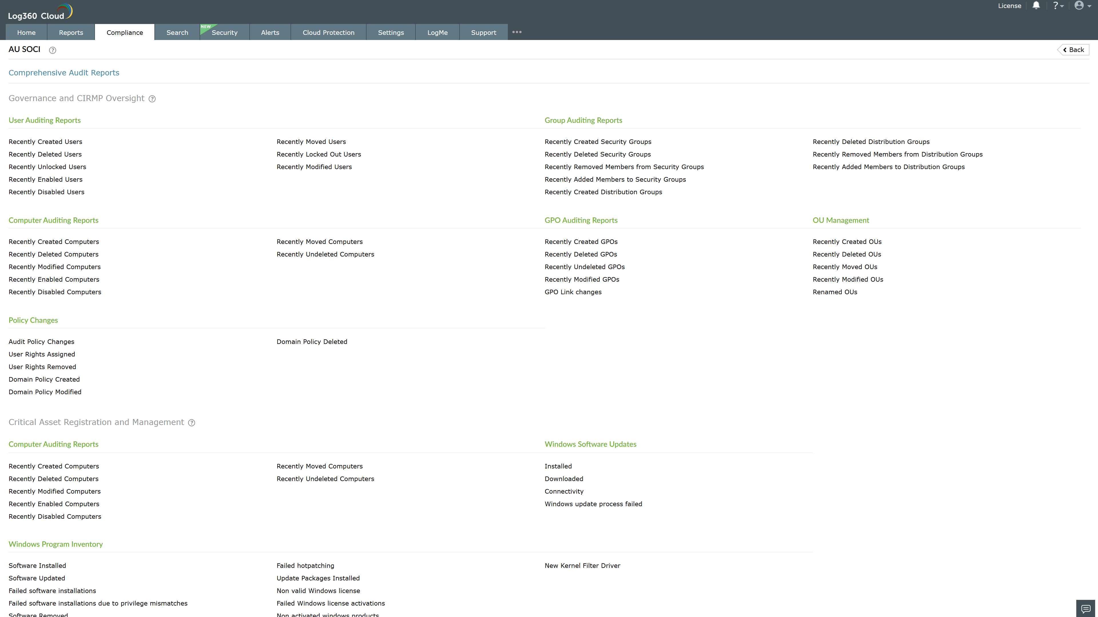
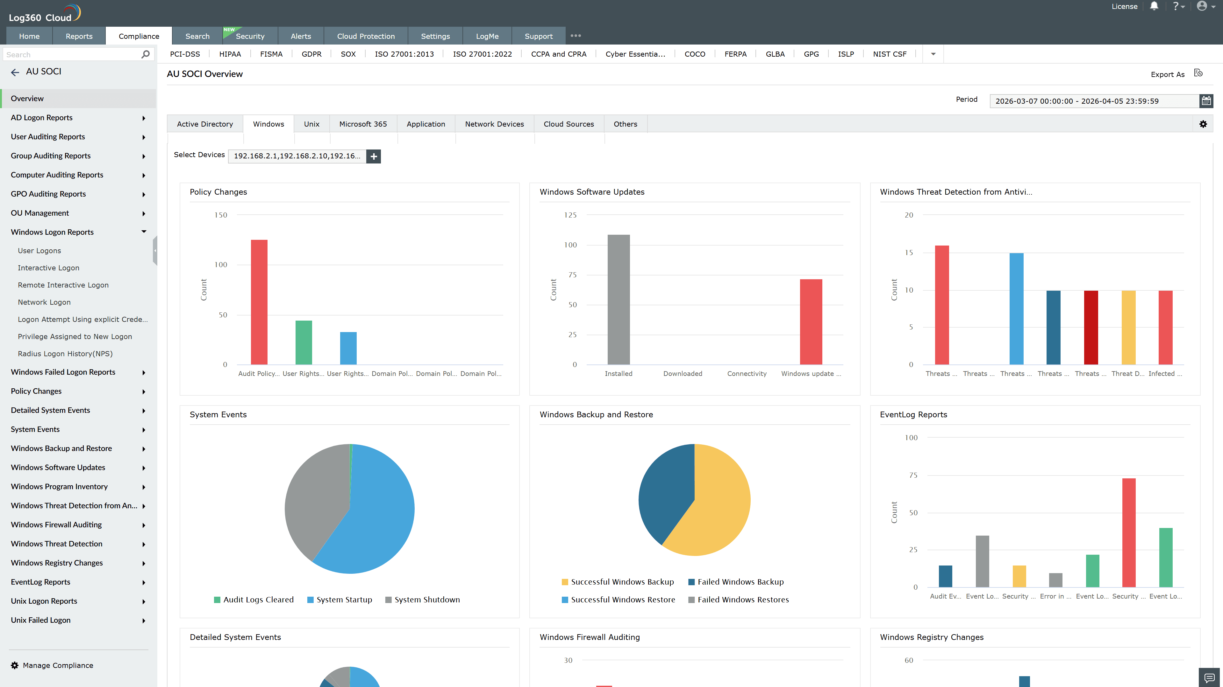
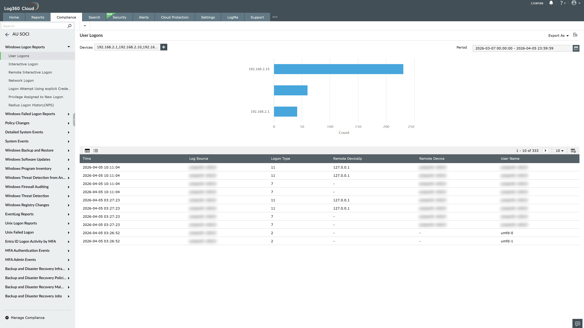
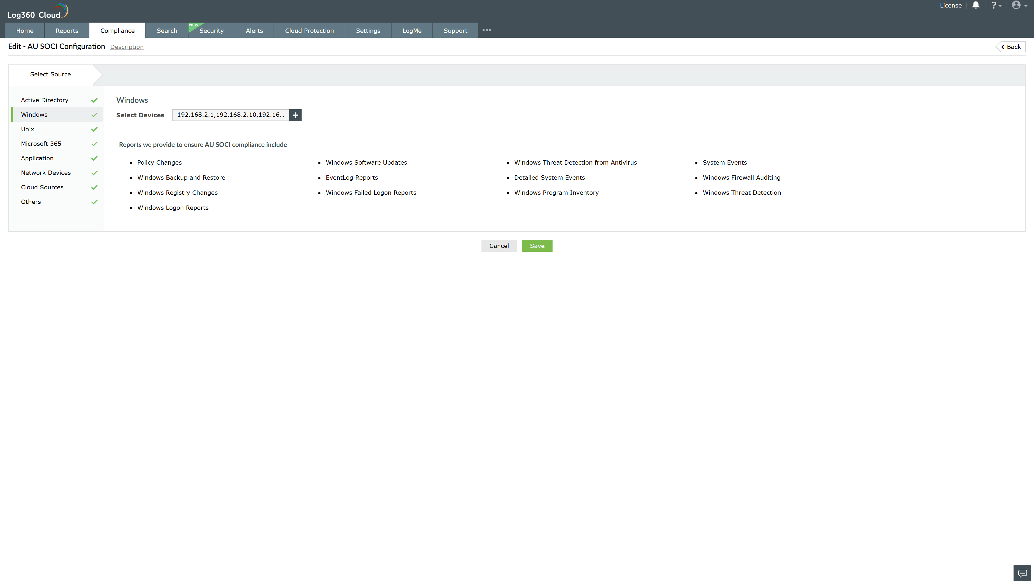
Valid Submission : Yes
Supported Editions : Free, Basic, Standard, Professional, MSSP
Help Document : https://www.manageengine.com/log-management/help/integrations/compliance-extensions.html
Help Video : Not provided
Tags : Log360, Compliance, Privacy monitoring, Data privacy, Regulatory compliance
Supported DCs : US, IN, JP, CA, AU, UK and EU
Privacy Policy:
Terms of Service:
Release Notes:
Predefined reports for the AU SOCI.

